PDL 12.1.
12.temats. Vikingu laikmets
- Definē jēdzienu vikingi!
__________________________________________________________________________________________________________________________________________________________________

- Kāpēc sākās vikingu laikmets?
- ___________________________________________________________________________
- ___________________________________________________________________________
- ___________________________________________________________________________

- Kāds bija vikingu dzīvesveids? Ar ko viņi nodarbojās?
- ______________________________________________________________________________________________________________________________________________________
- ______________________________________________________________________________________________________________________________________________________

- Ar kādu nolūku vikingi devās uz citām zemēm, ko tur darīja?
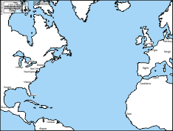
- ____________________________
____________________________
- ____________________________
____________________________
- ____________________________
____________________________
- ____________________________
____________________________
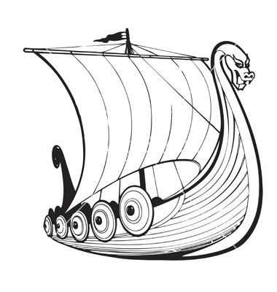

- Raksturo vikingu kuģa izskatu?
- ____________________________________
- ____________________________________
- ____________________________________

- Kā vikingi orientējās jūrā?
- ______________________________________________________________________________________________________________________________________________________
- ______________________________________________________________________________________________________________________________________________________

- Kad un kāpēc beidzās vikingu sirojumi?
____________________________________________________________________________________________________________________________________________________________________________________________________________________________________________________________________________________________________________________________________

- Kas, Tavuprāt, interesants ir vikingu sasniegumos, reliģiskajos priekšstatos un sadzīvē?
____________________________________________________________________________________________________________________________________________________________________________________________________________________________________________________________________________________________________________________________________

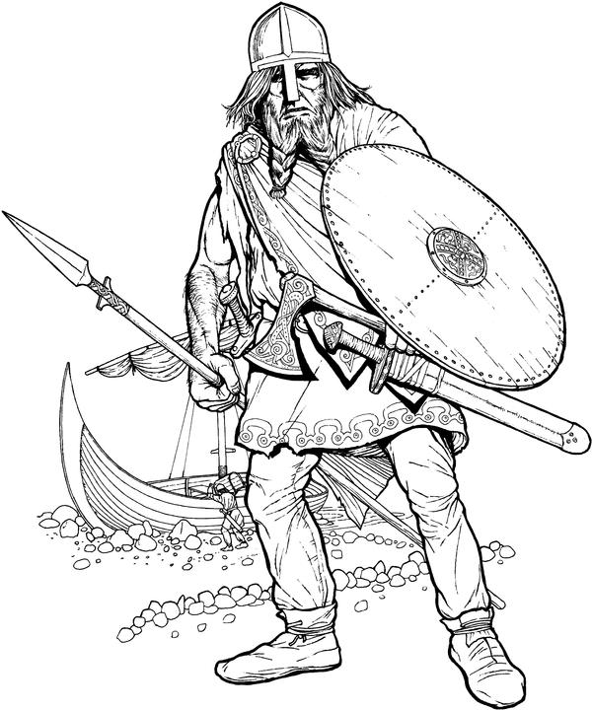
- Ja Tu būtu vikings, tad kādas lietas Tev vienmēr būtu līdzi? Paskaidro savu izvēli!
- _____________________________
_____________________________
_____________________________
- _____________________________
_____________________________
_____________________________
- _____________________________
_____________________________
_____________________________
- _____________________________
_____________________________
_____________________________
- _____________________________
_____________________________
_____________________________

- Ja Tev būtu iespēja vienu dienu pavadīt vikinga vietā, Tu…
________________________________________________________________________________________________________________________________________________________________________________________________________________________________________________________________________________________________________________________

- Kādas sekas atstājuši vikingi mūsdienās?
________________________________________________________________________________________________________________________________________________________________________________________________________________________________________________________________________________________________________________________

